

BEng (Hons) Software Engineering

Module Name | 4COSC006C- Software Development -I
Module Leader | Mr. Guhanathan Poravi
Assessment Type | Individual
Assessment Number | Stage 04
Student ID | 20231970 – IIT  W2149655 – UoW
Student Name | Mr. K. M. Palansuriya
Issue Date | Tuesday 19th Feb 2025
Submission Date | Monday 21st Apr 2025
Acknowledgement

The report is done as a requirement of the Computer Programming that is conducted by the Informatics Institute of Technology.
First, I would like to convey my sincere gratitude to our module leader, Mr.Guhanathan Poravi and other lecturers, without their guidance this coursework could not have been done properly. They always guided us and provided valuable support for the completion of this coursework.
I would also like to express my gratitude to the Informatics Institute of Technology for providing
us with the facilities necessary for pursuing this program of study to gain theoretical knowledge
and practical experience to do this report.
Finally, I would like to thank my family, friends, and the institute for their moral support and for accomplishing this coursework. Without them, this would not have been successful and possible.

Contents
Introduction 4
Purpose of using the GUI 4
GUI Interface Buttons 4
Test Cases and Results 5
Test Case 01 – Sort by Name 5
Test Case 02 – Sort by Due Date 6
Test Case 03 – Enter Task Name in Name Filter 7
Test Case 04 – User to enter Due Date filter 8
Test Case 05 – Enter column header to select priority 9
Test Case 06 – Check “High” from priority 10
Conclusion 12

Table 1 - Sort by Name 5
Table 2 - Sort by Due Date 6
Table 3 - Enter Task Name in Name Filter 7
Table 4 - User to enter Due Date filter 8
Table 5 - Enter column header to select priority 9
Table 6 - Check “High” from priority 10

Figure 1 - Sort by Name (GUI) 6
Figure 2 - Sort by Due Date (GUI) 7
Figure 3 - Enter Task Name in Name Filter (GUI) 8
Figure 4 - User to enter Due Date filter (GUI) 9
Figure 5 - Enter column header to select priority (GUI) 10
Figure 6 - Check “High” from priority (GUI) 11

Introduction

The personal task manager (GUI) features a user-friendly interface built using Tkinter designed to help users to manage their personal tasks effectively. All task data is stored in a tasks.json file, with each task containing a title, description, priority level and due date. At the top of the window users can apply filters to sort tasks by name, priority or due date. The center of the application showcases a table (Treeview) that displays each task’s details. Additionally, users can sort the tasks by clicking on column headers for better organization

Purpose of using the GUI

The purpose of the using the GUI interface enables users to view tasks from a JSON file in a tabular format, filter tasks by name, priority and due date and sort tasks by column headers using by name, priority and due date

GUI Interface Buttons

- Title Bar
- Displays the application title as Personal Task Manager

- Search and Filter Section

- Type any part of a task name to filter
- Choose High, Medium, or Low
- Filter tasks by due date YYY-MM-DD format
- Filter task list based on selected criteria

- Task Display Table

Treeview widget will display columns Task name, Description, Priority, Due date and tasks are shown in a structured table and clickable column header for sorting

- Sort Buttons

- Sort by Name
- Sort by Priority
- Sort by Due Date

Test Cases and Results

Test Case 01 – Sort by Name

Table 1 - Sort by Name
Test  Case | Input | Expected  Outcomes | Actual  Outcomes | Result
Sort by Name | Click “Sort by Name” | Tasks sorted alphabetically by name | Tasks sorted correctly in alphabetically order | Pass

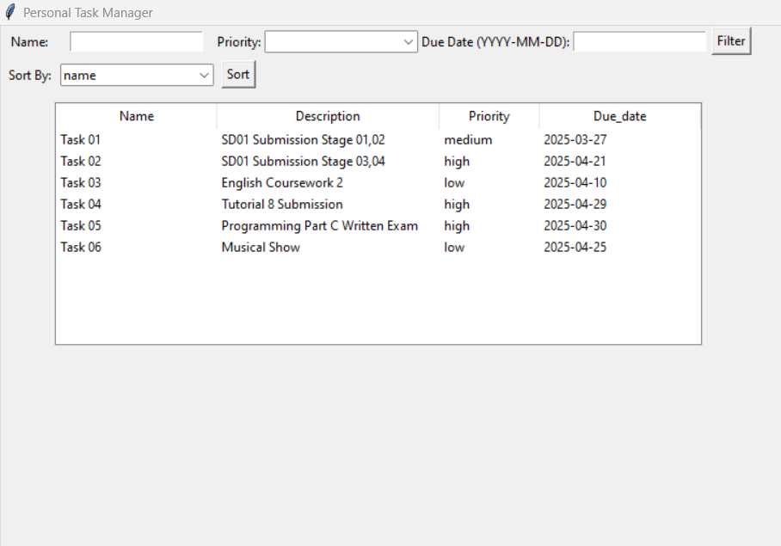
Figure 1 - Sort by Name (GUI)

Test Case 02 – Sort by Due Date

Table 2 - Sort by Due Date
Test  Case | Input | Expected  Outcomes | Actual  Outcomes | Result
Sort by Due Date | Click “Sort by Due Date” | Tasks sorted by ascending due  date | Tasks appear in correct date order | Pass

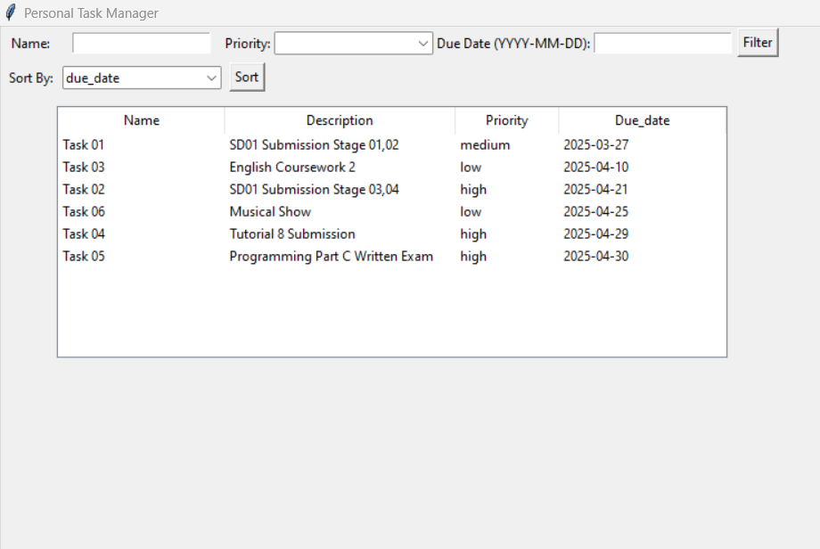
Figure 2 - Sort by Due Date (GUI)

Test Case 03 – Enter Task Name in Name Filter

Table 3 - Enter Task Name in Name Filter
Test  Case | Input | Expected  Outcomes | Actual  Outcomes | Result
Enter Task Name in Name Filter | Enter Task 02 in Name Filter | Only task with “Task 02” appears | Task filtered correctly | Pass

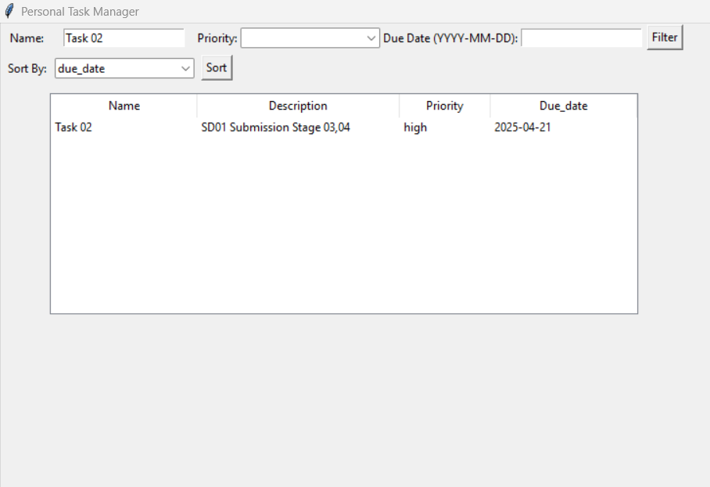
Figure 3 - Enter Task Name in Name Filter (GUI)

Test Case 04 – User to enter Due Date filter

Table 4 - User to enter Due Date filter
Test  Case | Input | Expected  Outcomes | Actual  Outcomes | Result
User to enter Due Date filter | Enter 2025-04-21 in Due date filter | Only tasks due on that date are shown | Task list correctly filtered | Pass

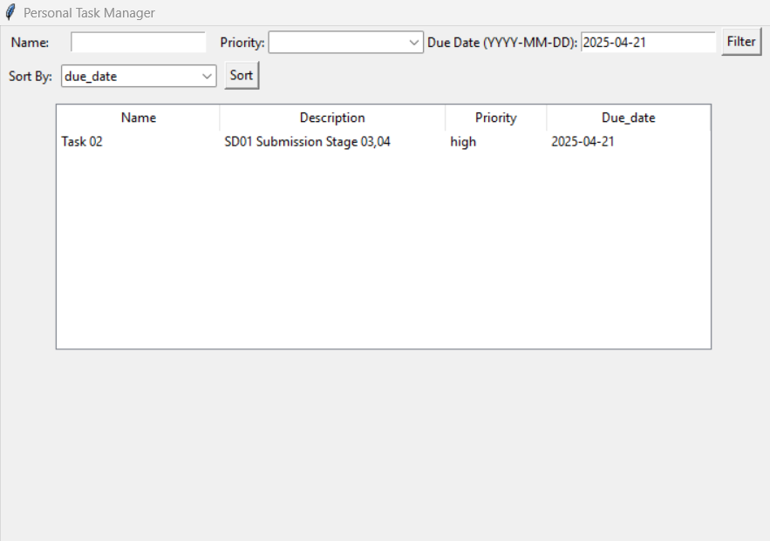
Figure 4 - User to enter Due Date filter (GUI)

Test Case 05 – Enter column header to select priority

Table 5 - Enter column header to select priority
Test  Case | Input | Expected  Outcomes | Actual  Outcomes | Result
Enter column header to select priority | Click column header “priority” | Tasks sorted by priority | Tasks recorded correctly | Pass

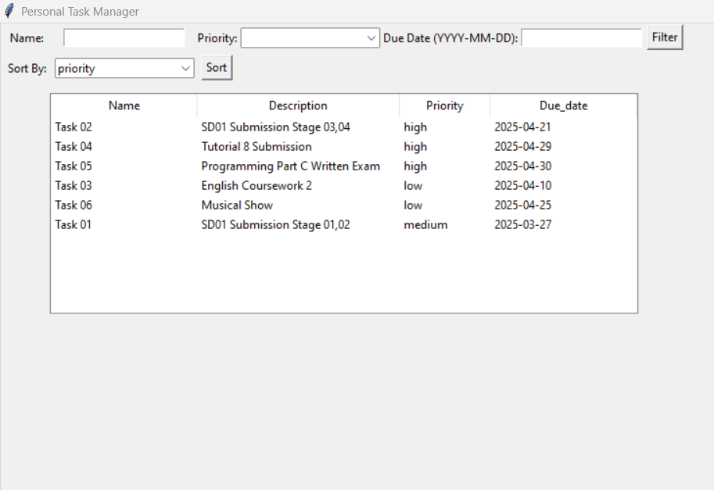
Figure 5 - Enter column header to select priority (GUI)

Test Case 06 – Check “High” from priority

Table 6 - Check “High” from priority
Test  Case | Input | Expected  Outcomes | Actual  Outcomes | Result
Check “High” from priority | Click “High” from priority dropdown | Only “High” priority tasks are shown | Filter applied successfully | Pass

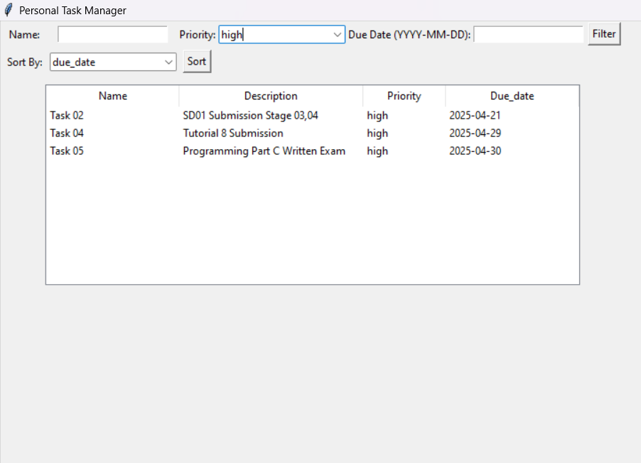

Figure 6 - Check “High” from priority (GUI)

Conclusion

In conclusion, the GUI- based personal task manager successfully provides an organized and interactive platform for managing personal tasks. With features such as filtering, sorting and clear display of task details, users can effectively handle tasks. The use of Tkinter along with JSON storage ensures a smooth and user-friendly experience. Making task management and effective

